


Abuse in Care public apology:

Public Service Commission


Sir Brian Roche
Public Services Commissioner
Published: November 2024

Before you start


This Easy Read document talks about abuse.



This information may upset some people when they are reading it.

This information is not meant to scare anyone.

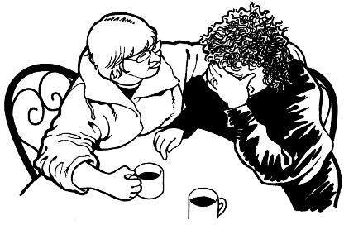
If you are upset after reading this Easy Read document you can talk to your:

- whānau / family
- friends.


You can contact the Survivor Experiences Service for support.

In New Zealand you can phone:

0800 456 090

If you are calling from Australia you can phone:


1 800 456 032

You can call this number:

between 8:30 am to 4:30 pm
from Monday to Friday.



These times are for the New Zealand time zones.


You can also send a text to the Survivor Experiences Service.


In New Zealand you can send a text to:

8328

If you are texting from Australia you can send a text to:

+61 438 384 957


It does not cost any money to
call / text the Survivor Experiences Service.


You can also send the Survivor Experiences Service an email at:

contact@survivorexperiences.govt.nz

About this document




On the 12 November 2024 different parts of Government made a public apology to people who had been abused while in:
- state / government care

- faith-based care.

Sorry

A public apology is when someone says sorry to a group of people in a way that means everyone can be a part of what is said.

The Easy Read is about the public apology made by the Public Service Commissioner Sir Brian Roche.

In this document we will call the:

- Public Service Commissioner
the Commissioner

- Public Service Commission
the PSC.


This Easy Read document has quotes of what Sir Brian Roache said in the apology from the Public Services Commission.

“Hello”

A quote is an exact copy in writing
of what someone has said.

The quotes are in yellow boxes like this.


You can read the full apology on the Public Service Commission website at:

www.publicservice.govt.nz

The apology from the

Public Service Commission


The Commissioner acknowledges that there are people at the public apology who have been affected by abuse in care like:

survivors
their whānau / families.


Acknowledge means you:
- say you know that something happened

- understand something is true.

People who have been through abuse in care are called survivors.

The Commissioner also acknowledges that there are survivors who have already died.

“As the Public Service Commissioner, I unreservedly apologise for the abuse and harm inflicted on you by the State.”


Abuse and harm inflicted means someone was hurt very badly by someone else.

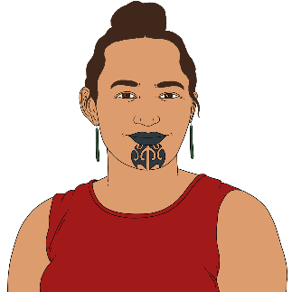
This suffering happened to some people more than others like:
Māori

Pacific people
disabled people.

The PSC failed survivors by not making sure that the right things were
being done by:

public servants
public service chief executives.

Public servants are people who:
work for the Government
are paid by the Government.


Public service chief executives are the people who make decisions for the public services they run.


The Commissioner says the public service he leads is to blame for these things.
“I regret that we did not always deliver on these responsibilities”.

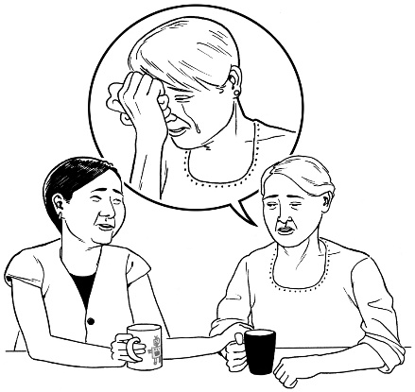
To regret something means that someone:
feels very bad about something
wishes it had not happened.

“Our public service should have kept people in its care safe and protected.

Complaints of abuse and neglect in care should have been responded to appropriately and abusers held to account.

I deeply regret our failure to do this”.

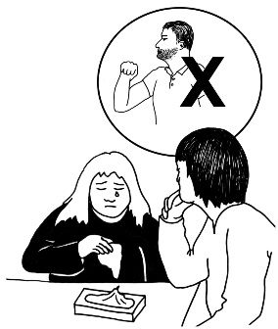
Responded to appropriately
means that the PSC should have:
- listened to the complaints
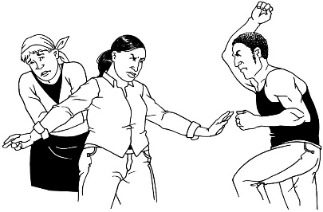
- done something about what
was being complained about.

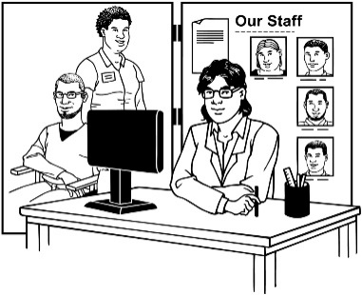
Agencies that are part of the public service have not always had good communication with each other.


Communication is how people share information with each other.


People communicate in different ways like:

talking in person / on the phone
sending emails / letters.
Agencies not having good communication means that sometimes we failed to support:
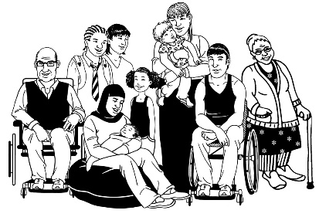
people of all ages who are in care
their families
communities.

The Commissioner said:
-
“I also acknowledge that we should have done more to ensure that timely and appropriate redress
was made available to survivors.”


Ensure means to make sure.

Timely means in the right amount of time.


Appropriate means what was offered as redress would be the right thing for survivors.


Redress means someone:
agrees that something bad has happened
does something to try to:

- put things right
- make up for any harm that has been done.

Redress can be things like:
saying sorry
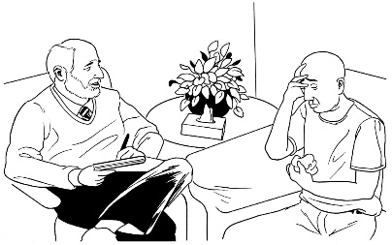
giving money as a way of saying sorry
giving other kinds of support like counselling.
“As a public service we haven’t necessarily represented the diversity of the people we are
meant to serve or been as inclusive as we should have been.”


Representing means speaking up for the needs of people from
different groups.


Diversity means having lots of different kinds of people from different groups.


Inclusive means making sure everyone can be part of something.

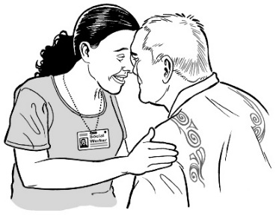
The public service has not always worked well in supporting Māori in the ways that they need.


The PSC needs to make sure that representing / supporting diverse communities is very important to the public service.


The PSC has so far failed to represent diverse communities.

“As the Public Service Commissioner, I accept responsibility for these past failings, and I deeply regret that you suffered the harm and abuse these failings allowed.

I apologise for that.”


Responsibility means that
someone will take the blame if something goes wrong.

“I know nothing I say today can ever fix these past wrongs.”


The PSC will make changes that will make sure people who are in state / government care will be safe from harm.

The PSC is making some changes to make sure:
people in care are kept safe

public service agencies work together
public service agencies are in charge of making the changes needed.

The apology from the Public Service Commission: what changes will be made

Creating a Crown Response Office as part of the PSC


Creating a Crown Response Office as part of the PSC is one of the changes the Government has made.


A Crown Response Office is the group of people who handle the Government response to the Royal Commission of Inquiry Abuse in Care report.

In this Easy Read document we will call the Crown Response Office the CRO.

This Crown Response Office has its own Chief Executive.


The Chief Executive is the person who is in charge of the Crown Response Office at the PSC.

In this Easy Read document we will call the Chief Executive of the CRO the CE of the CRO.
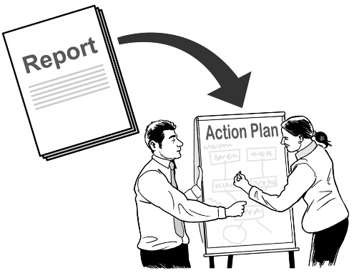

The CE of the CRO is in charge of the Government response to the report from the Royal Commission of Inquiry Abuse in Care.


Having the CRO as part of the PSC will make sure they are not run by agencies who are part of the care system.


Having the CRO as part of the PSC will also make sure any work done will:
be thought of as very important

be watched closely
have people who know what they are doing leading it.

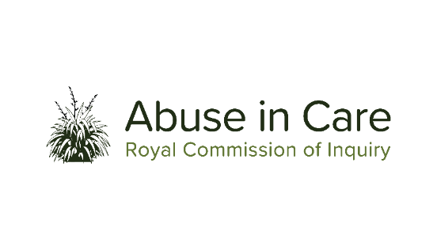
Doing this was a key recommendation from the Royal Commission of Inquiry.


A key recommendation is an important thing that the Royal Commission of Inquiry says they think should happen.


1 of the statutory Deputy Public Service Commissioners now runs a board of chief executives.


A statutory Deputy Public Service Commissioner is someone who supports the Commissioner in their work.


They can do the same things the Commissioner can do.

They run the board to make sure the chief executives work together.


The PSC is working with agencies to address things that some people who worked for the public service did wrong on their own.

The Commission is making sure that public servants know how they need to:
behave

treat people.

There will be ways for people who see something wrong to speak up.



People will be able to speak up through an integrity programme for everyone in the public service.

The PSC will talk soon about what the integrity programme is.

“I know that the Public Service must do better. And it’s my commitment to you all that we will do better.


This is just the beginning; there is much more to do.”
I will

A commitment is a strong promise.

This information has been written by the Public Service Commission.


It has been translated into Easy Read by the Make it Easy Kia Māmā Mai service of People First New Zealand Ngā Tāngata Tuatahi.

The ideas in this document are not the ideas of People First New Zealand Ngā Tāngata Tuatahi.

Make it Easy uses images from:


- Changepeople.org


            - Photosymbols.com

- SGC Image Works
- Huriana Kopeke-Te Aho
- T. Wood.

All images used in this Easy Read document are subject to copyright rules and cannot be used without permission.

